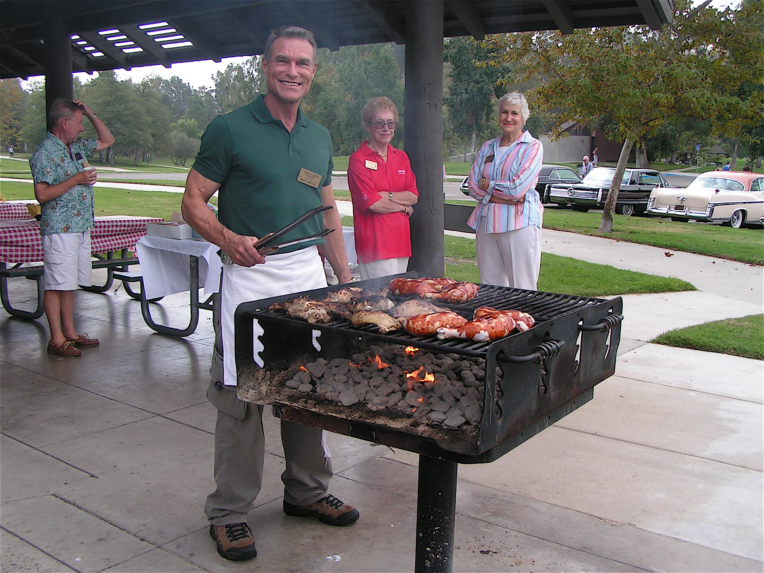

WHAT TO BRING: Your beautiful Imperials, $5 for the park entrance fee, $10 per person for the food and drink. We’ll collect the money at the picnic.

DIRECTIONS: FROM I-5 take the LA PAZ exit WEST. Shelter #4 can be seen on your left from the entrance.

PLEASE RSVP (so we will know how much food to buy) by September 25th to either:
MARC HAMPTON 760-323-0062 / marc_hampton@hotmail.com
NANNETTE CLARK 858-277-9870 / nannetteclark@att.net See you there!

Fourteenth Annual Picnic

Saturday, September 28, 2013
Laguna Niguel Park, Shelter #4
28241 La Paz Road
Laguna Niguel, 92677
10:00-am to 3:00-pm

Starring our own fabulous chef
at the grill:
Marc D. Hampton

Remember to wear your name badge
We’ll be having the $20 drawing.

REMEMBER: “NO ALCOHOL IN THE PARK”

